## Apache Airflow Overview

Welcome to Apache Airflow Overview.

After watching this video, you will be able to:

Recognize Apache Airflow as a platform to programmatically author, schedule, and monitor

workflows.

List the main features and principles of Apache Airflow.

And, list common use cases for Apache Airflow.

Apache Airflow is a great open source workflow orchestration tool that is supported by an

active community.

It is a platform that lets you build and run workflows, such as batch data pipelines.

With Apache Airflow, a workflow is represented as a DAG (a Directed Acyclic Graph), and contains

individual pieces of work called tasks, arranged with dependencies.

And, note that unlike Big Data tools such as Apache Kafka, Apache Storm, Apache Spark,

or Flink, Apache Airflow is not a data streaming solution. It is primarily a workflow manager.

Let’s take a look at a simplified overview of Apache Airflow’s basic components.

Airflow comes with a built-in Scheduler, which handles the triggering of all scheduled workflows.

The Scheduler is responsible for submitting individual tasks from each scheduled workflow

to the Executor.

The Executor handles the running of these tasks by assigning them to Workers, which

then run the tasks.

The Web Server , serves Airflow’s powerful interactive User Interface.

From this UI, you can inspect, trigger and debug any of your DAGs and their individual

tasks.

The DAG Directory contains all of your DAG files, ready to be accessed by the Scheduler,

the Executor, and each of its employed Workers.

Finally, Airflow hosts a Metadata Database, which is used by the Scheduler, Executor,

and the Web Server to store the state of each DAG and its tasks.

A DAG specifies the dependencies between tasks, and the order in which to execute them. The

tasks themselves describe what to do. In this example DAG, the tasks include data ingestion,

data analysis, saving the data, generating reports, and triggering other systems, such

as reporting any errors by email.

Let’s have a look at the life cycle of a task’s state.

In this diagram, you can see how Apache Airflow might assign states to a task during its life

cycle.

No status: This means that the task has not yet been queued for execution.

Scheduled: The scheduler has determined that the task’s dependencies are met and has

scheduled it to run.

Removed: For some reason, the task has vanished from the DAG since the run started.

Upstream failed: An upstream task has failed.

Queued: The task has been assigned to the Executor and is waiting for a worker to become

available.

Running: The task is being run by a worker.

Success: The task finished running without errors.

Failed: The task had an error during execution and failed to run, and

Up for retry: The task failed but has retry attempts left and will be rescheduled.

Ideally, a task should flow through the scheduler from ‘no status’, to ‘scheduled’,

to ‘queued’, to ‘running’, and finally to ‘success.’

Now, let’s have a look at the five main features and benefits of Apache Airflow.

Pure Python

Create your workflows using standard Python. This allows you to maintain full flexibility

when building your data pipelines.

Useful UI

Monitor, schedule, and manage your workflows via a sophisticated web app, offering you

full insight into the status of your tasks.

Integration

Apache Airflow provides many plug-and-play integrations, such as IBM Cloudant, that are

ready to execute your tasks.

Easy to Use

Anyone with Python knowledge can deploy a workflow. Airflow does not limit the scope

of your pipelines.

And finally, the open source feature.

Whenever you want to share your improvement, you can do this by opening a pull request.

Airflow has many active users who are sharing their experiences in the Apache Airflow community.

Apache Airflow pipelines are built on four main principles. They are:

Scalable: Airflow has a modular architecture and uses a message queue to orchestrate an

arbitrary number of workers. It is ready to scale to infinity.

Dynamic: Airflow pipelines are defined in Python, and allow dynamic pipeline generation.

Thus, your pipelines can contain multiple simultaneous tasks.

Extensible: You can easily define your own operators and extend libraries to suit your

environment.

And, Lean: Airflow pipelines are lean and explicit. Parameterization is built into its

core using the powerful Jinja templating engine.

Apache Airflow has supported many companies in reaching their goals. For example,

Sift used Airflow for defining and organizing Machine Learning pipeline dependencies,

SeniorLink increased the visibility of their batch processes and decoupled them,

Experity deployed Airflow as an enterprise scheduling tool, and

Onefootball used Airflow to orchestrate SQL transformations in their data warehouses,

and to send daily analytics emails.

In this video, you learned that:

Apache Airflow is a platform to programmatically author, schedule, and monitor workflows.

The five main features of Airflow are its use of Python, its intuitive and useful user

interface, extensive plug-and-play integrations, ease of use, and the fact that it is open

source.

You also learned that Apache Airflow is scalable, dynamic, extensible, and lean.

And finally, defining and organizing machine learning pipeline dependencies with Apache

Airflow is one of the common use cases.

Work flow orchestration tool

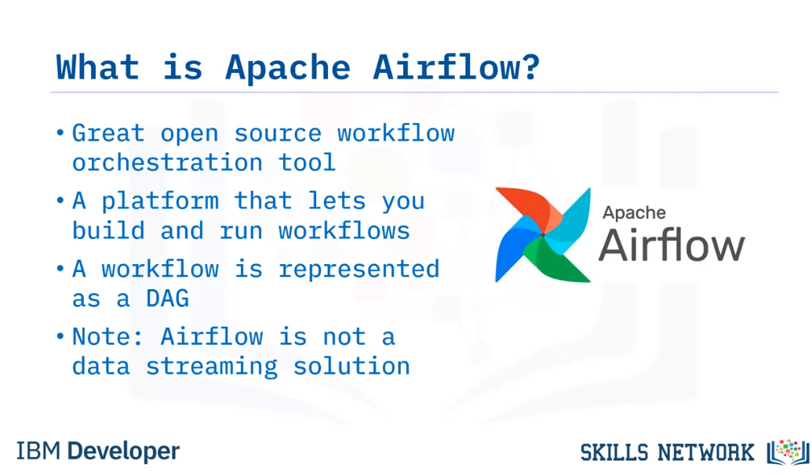

Airflow Architecture

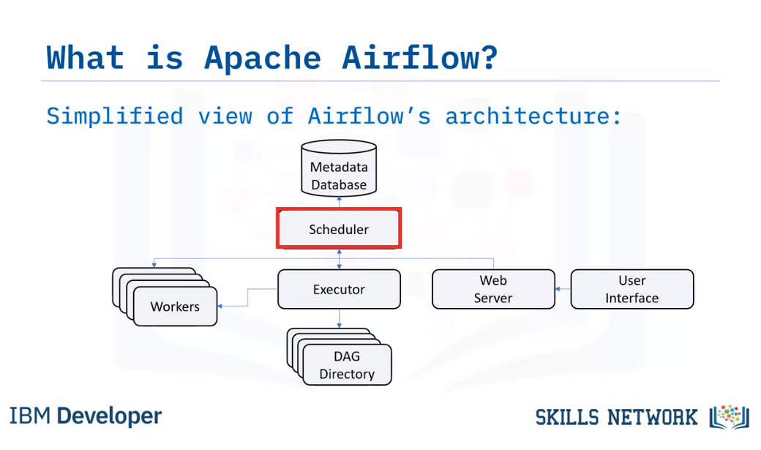Airflow comes with a built-in Scheduler, which handles the triggering of all scheduled workflows.

The Scheduler is responsible for submitting individual tasks from each scheduled workflow

to the Executor.

The Executor handles the running of these tasks by assigning them to Workers, which

then run the tasks.

The Web Server , serves Airflow’s powerful interactive User Interface.

From this UI, you can inspect, trigger and debug any of your DAGs and their individual

tasks.

The DAG Directory contains all of your DAG files, ready to be accessed by the Scheduler,

the Executor, and each of its employed Workers.

Finally, Airflow hosts a Metadata Database, which is used by the Scheduler, Executor,

and the Web Server to store the state of each DAG and its tasks.

A DAG specifies the dependencies between tasks, and the order in which to execute them. The

tasks themselves describe what to do.

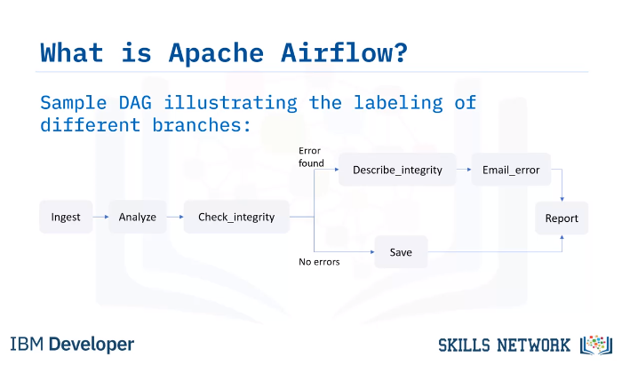

In this example DAG, the tasks include data ingestion,

data analysis, saving the data, generating reports, and triggering other systems, such

as reporting any errors by email.

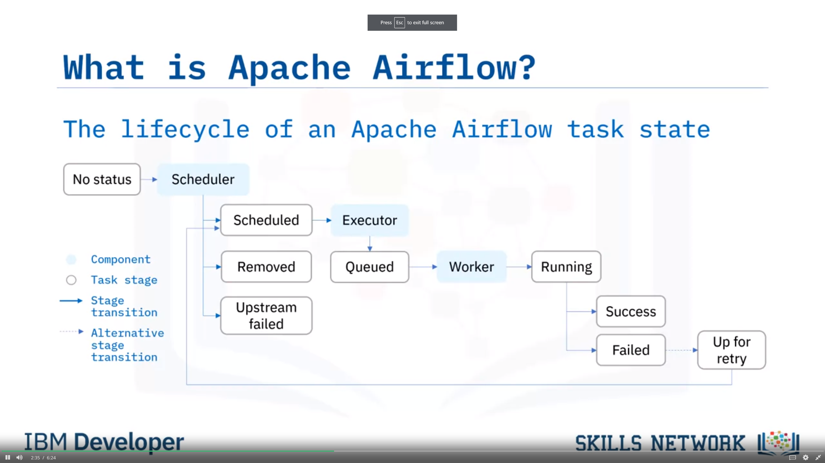

et’s have a look at the life cycle of a task’s state.

In this diagram, you can see how Apache Airflow might assign states to a task during its life

cycle.

No status: This means that the task has not yet been queued for execution.

Scheduled: The scheduler has determined that the task’s dependencies are met and has

scheduled it to run.

Removed: For some reason, the task has vanished from the DAG since the run started.

Upstream failed: An upstream task has failed.

Queued: The task has been assigned to the Executor and is waiting for a worker to become

available.

Running: The task is being run by a worker.

Success: The task finished running without errors.

Failed: The task had an error during execution and failed to run, and

Up for retry: The task failed but has retry attempts left and will be rescheduled.

Ideally, a task should flow through the scheduler from ‘no status’, to ‘scheduled’,

to ‘queued’, to ‘running’, and finally to ‘success.’

Apache Airflow Features

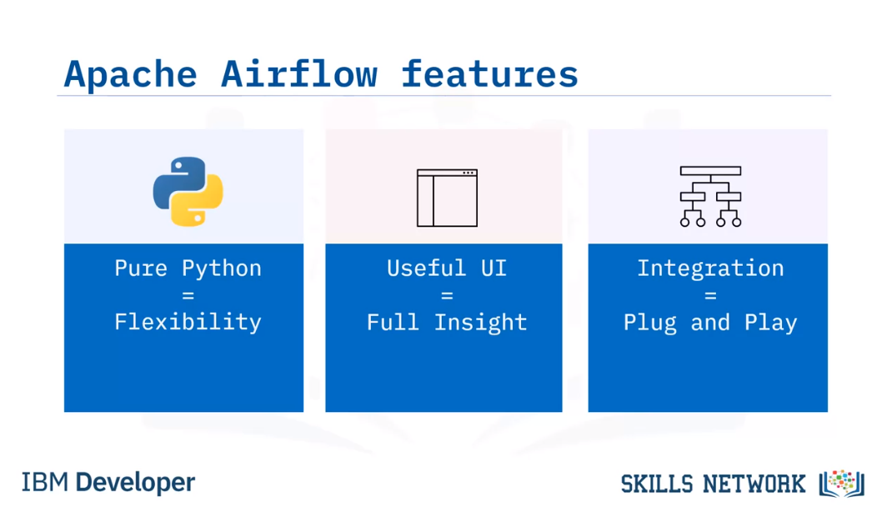

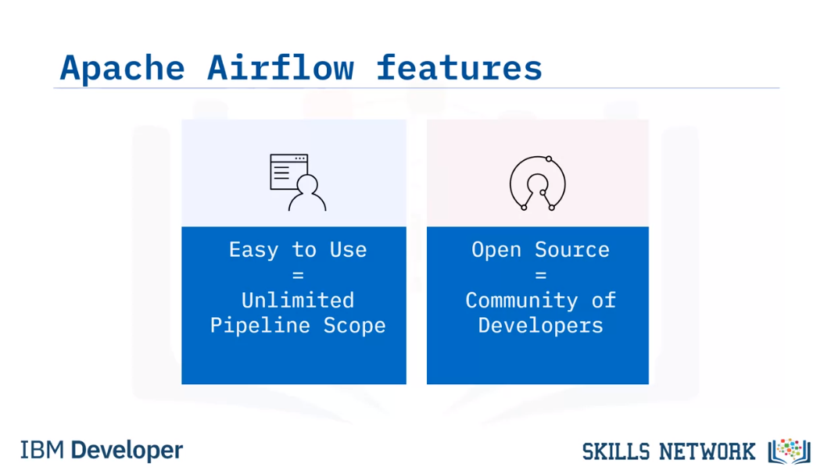

Apache Airflow principles

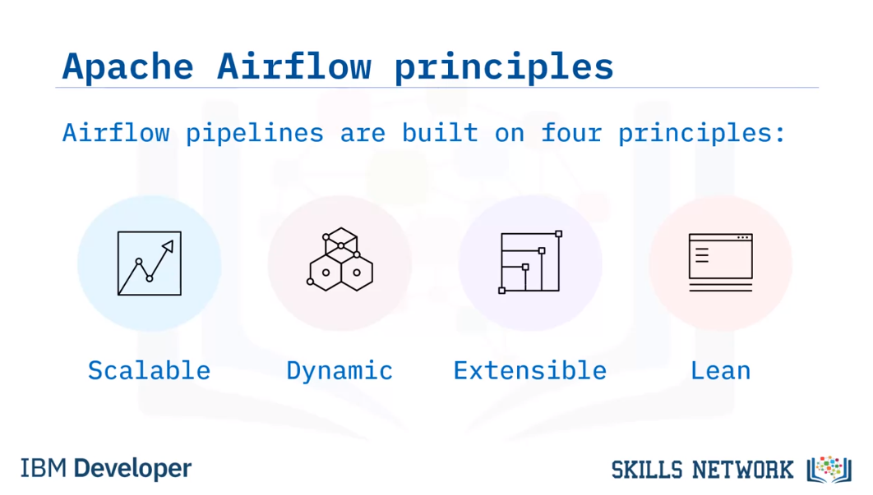

Scalable: Airflow has a modular architecture and uses a message queue to orchestrate an

arbitrary number of workers. It is ready to scale to infinity.

Dynamic: Airflow pipelines are defined in Python, and allow dynamic pipeline generation.

Thus, your pipelines can contain multiple simultaneous tasks.

Extensible: You can easily define your own operators and extend libraries to suit your

environment.

And, Lean: Airflow pipelines are lean and explicit. Parameterization is built into its

core using the powerful Jinja templating engine.

Use Cases

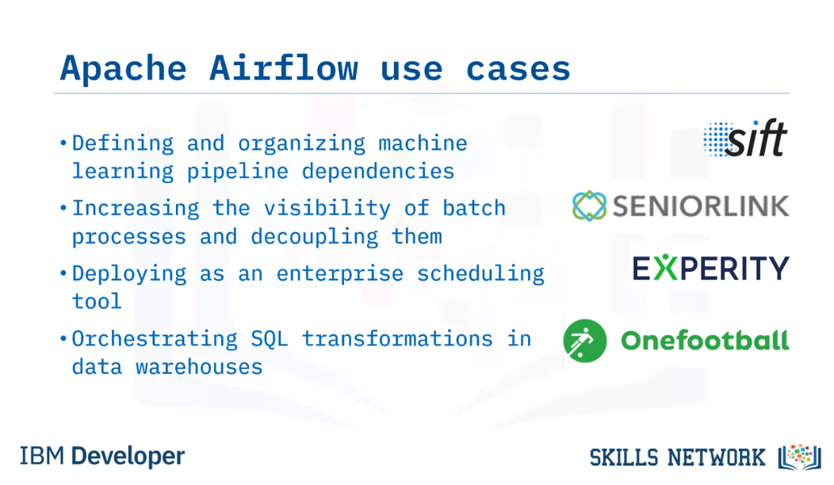

## Advantages of Using Data Pipelines as DAGs in Apache Airflow

Welcome to

Advantages of Representing Data Pipelines as DAGs in Apache Airflow.

After watching this video, you will be able to:

Define what a Directed Acyclic Graph, or DAG, is.

Describe workflows as DAGs of tasks and dependencies.

Outline the components of a DAG definition file.

Describe how Apache Airflow Scheduler executes tasks on an array of workers, and

List key advantages of defining workflows as code.

A 'DAG' is a special kind of graph, called a directed acyclic graph.

A simple graph consists of nodes and edges, like this. Here the circles are called

nodes, and the lines connecting pairs of nodes are called edges.

A directed graph is also a graph, but it has a bit more structure. As you can see here,

each edge has a specified direction. It connects a starting node with another node.

And lastly, the acyclic part means there are no loops, or sequences of directed

edges that return to a node in the chain, such as the red cycle shown here.

Let's take a look at a few examples of DAGs.

The simplest nontrivial DAG has a single directed edge and looks like

this. It has a single root node which is connected to a single terminal node.

Here's another DAG, which we've already seen. It also has single root and terminal nodes.

Here's an example of a tree , which is a commonly used graph for representing

family trees or directory structures.

All trees are DAGs, but not all DAGs are trees. For example,

this DAG is not a tree since it has more than one root node.

A DAG doesn't impose those restrictions, so a single node can have multiple parents

and there may be multiple nodes with no parents.

DAGs are used to represent workflows or pipelines in Apache Airflow.

Each task performed by your data pipeline is represented as a node in a DAG, while

each of the dependencies between two tasks in your pipeline are represented as a directed

edge in the DAG. In other words, edges define the order in which the two tasks should run.

Thus, DAGs are used in Airflow to define what tasks should run,

and in what sequence they should run.

A DAG is defined in a Python script, which represents the DAG’s structure.

Thus, the tasks and their dependencies are defined as code.

Also, scheduling instructions are specified as code in the DAG's script.

Let's take a closer look at the nodes, or tasks in a DAG.

Just like the DAG itself, each task performed within your DAG is also written in Python.

Each task implements an operator: for example, a Python operator is used to deploy some Python

code, a SQL operator to run a SQL query, and a Bash operator can be used to run a Bash command.

Operators are used to define what each task in your DAG does.

Sensors are a class of operators which are used to poll for a certain time or condition to be met.

For example, you can use a sensor to check every 30 seconds whether a file exists,

or whether another DAG has finished running.

There are many other types of operators, including email and HTTP request operators.

An Apache Airflow DAG is a python script consisting of the following logical blocks:

Library imports

DAG arguments

DAG definition

Task definitions

Task pipeline

Let's briefly go over an example.

The first block of your DAG definition script

is where you import any Python libraries that you require. For example, the ‘from

airflow import DAG’ command to import the DAG module from the Airflow collection.

The next block of code is for specifying default arguments for your DAG,

such as its default ‘start date’.

Next comes the DAG definition, or instantiation block for your DAG,

which specifies things like your default arguments.

Continuing along with our example DAG code, individual task definitions,

which are the nodes of the DAG, form your DAG’s next building block.

In this example we have two tasks, which happen to be Bash operators.

Finally, the task pipeline specifies the dependencies between your tasks.

Here 'task two' depends on the result of 'task

one'. And this forms the last logical block of your DAG script.

Your new DAG has been created, but it hasn't yet been deployed. To that end,

Airflow Scheduler is designed to run as a persistent service

within an Airflow production environment.

Apache Airflow Scheduler can be used to deploy your workflow on an array of workers.

It follows the tasks and dependencies that you specified in your DAG.

Once you start an Airflow Scheduler instance,

your DAGs will start running based on the 'start date' you specified as code in each of your DAGs.

After that, the Scheduler triggers each subsequent DAG run

according to the schedule interval you specified.

One of the key advantages of Apache Airflow's approach to representing data pipelines as

DAGs is the fact that they are expressed as code.

When workflows are defined as code, they become more

Maintainable: Developers can follow explicitly what

has been specified, by reading the code.

Versionable: Code revisions can easily be tracked by a version control system such as Git.

Collaborative: Teams of developers can easily collaborate

on both development and maintenance of the code for the entire workflow, and

Testable: Any revisions can be passed through

unit tests to ensure the code still works as intended.

In this video, you learned that:

In Apache Airflow, DAGs are workflows defined as Python code.

Tasks, which are the nodes in your DAG,

are created by implementing Airflow's built-in operators.

Pipelines are specified as dependencies between tasks,

which are the directed edges between nodes in your DAG.

Airflow Scheduler schedules and deploys your DAGs.

And finally, the key advantage of Apache Airflow's approach to representing data pipelines as

DAGs is the fact that they are expressed as code.

Accordingly, it makes your data pipelines more maintainable, testable, and collaborative.

What is a DAG

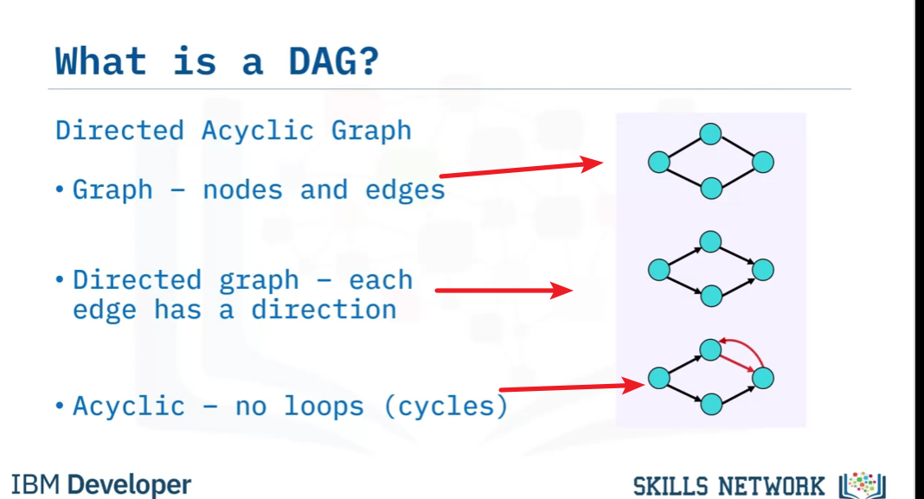

All tree are DAGs

What is DAG in Airflow

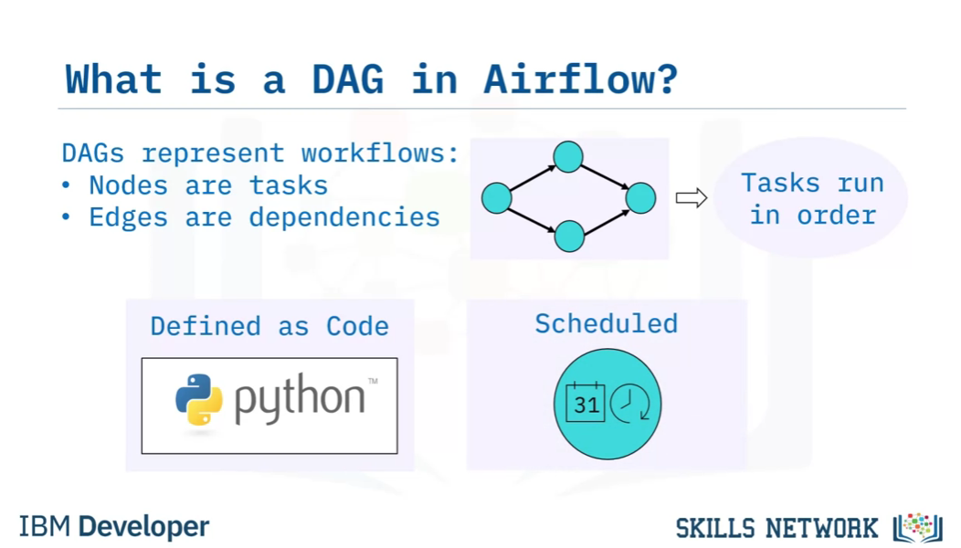

**Tasks and Operations**

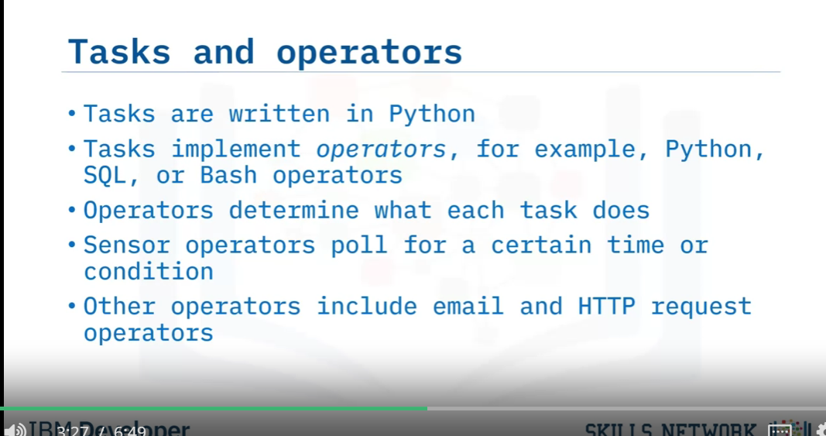

DAG Definition Components

Library Imports

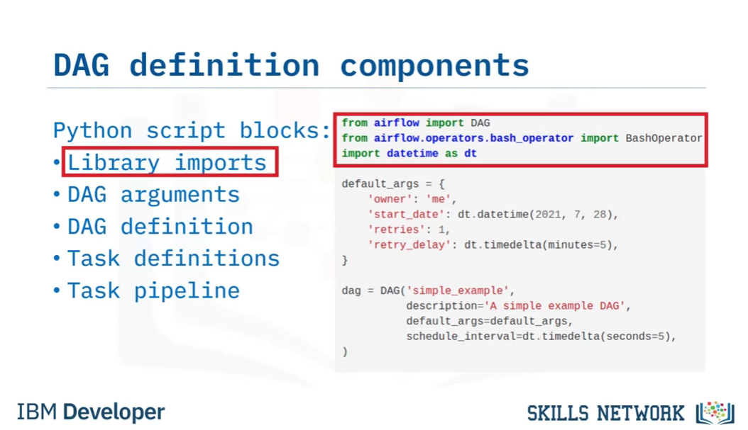

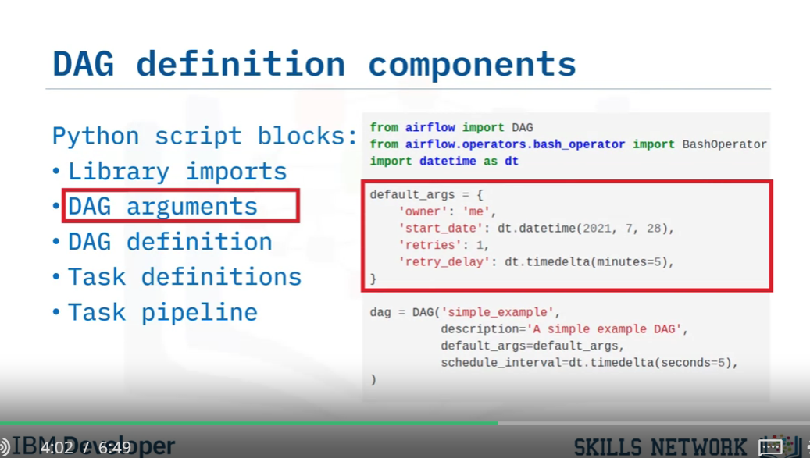

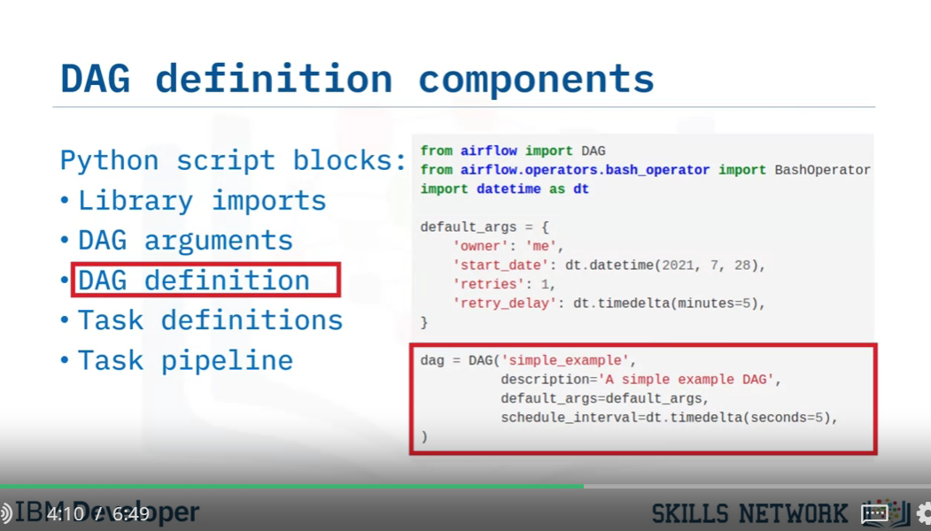

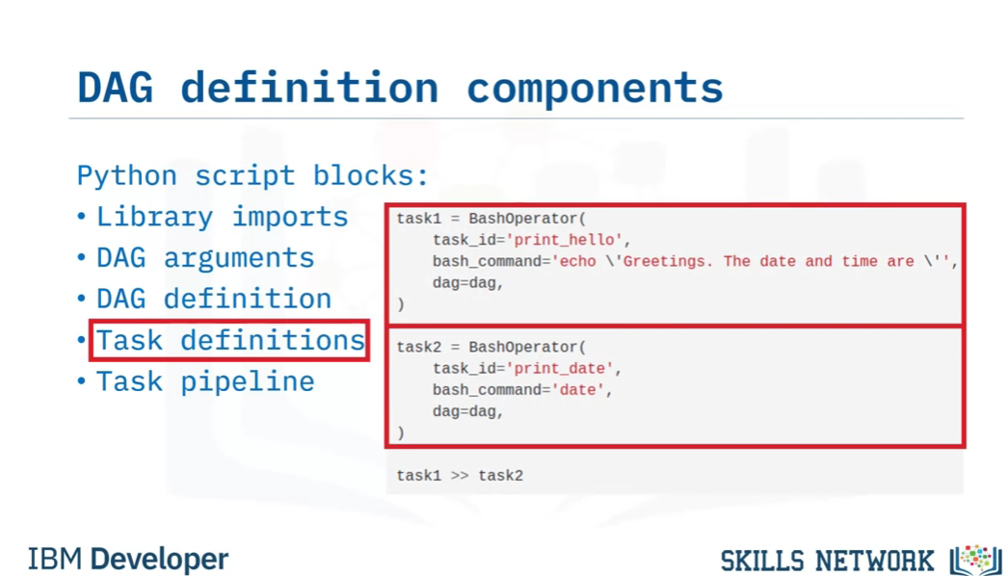

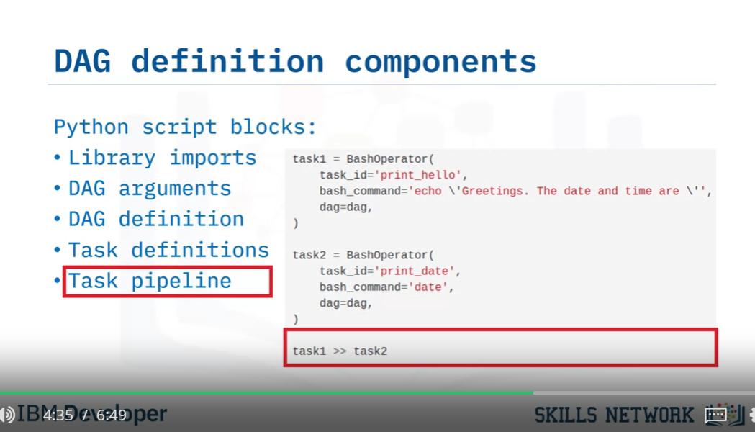

Airflow Scheduler

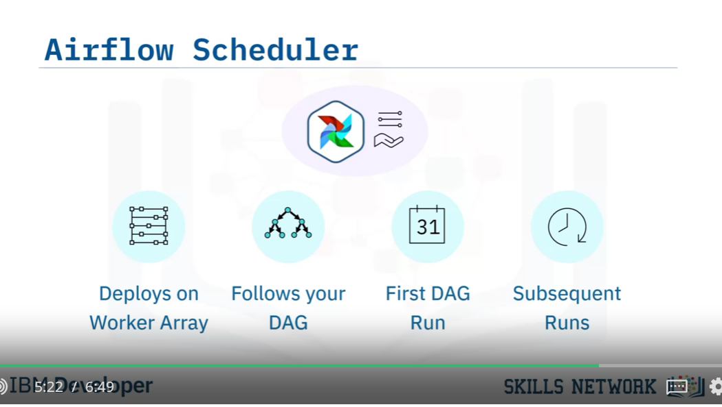

Advantage of workflows as code

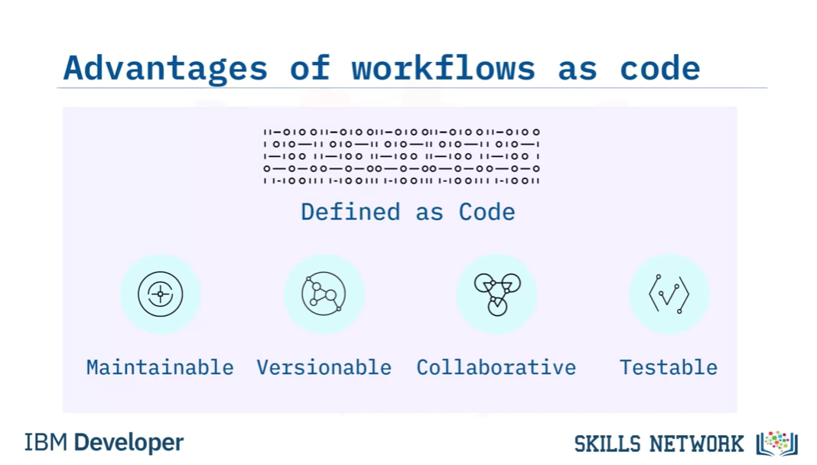

## Apache Airflow UI

Welcome to Apache Airflow UI.

After watching this video, you will be able to:

Identify current DAGs in your environment.

List different ways to visualize a specific DAG.

Review the code that defines your DAG.

Analyze the duration of each task in your DAG over multiple runs.

And, select context metadata for any task instance.

​Here's what the landing page for the Apache Airflow User Interface looks like in your

browser.

It defaults to the 'DAGs View,' which is a table containing data about each DAG

in your environment.

Each row displays interactive information about a DAG in your environment, such as

Each DAG's name;

Its run schedule, in this case in the crontab format;

The DAG's owner. This one is a built-in example from Airflow;

The status of the tasks from the current or most recent DAG run;

The status of all previous DAG runs;

Plus a collection of quick-links to drill down into more information related to the

DAG.

On the far left, you can drill down to access more interactive details, and

in the next column you can toggle to pause a DAG. All of the DAGs here are currently

not running.

You can visualize DAGs in several ways, as follows.

Start by clicking on the name of the DAG you want to visualize. This DAG, called ‘simple

example’, happens to be running in production, as you can see here by the ‘on’ button.

Play video starting at :1:39 and follow transcript1:39

Your DAG's 'Tree View' opens by default when you click on its name.

It shows a timeline of the status of your DAG and its tasks for each run.

Here, you can select the base-date and the number of runs to display.

Each status is color-coded according to the legend, displayed here.

You can also hover your mouse pointer over any task in the timeline to view more information

about it.

Here's another DAG, this time displayed in 'Graph View'. At the bottom of the screen

you can see your DAG’s tasks and dependencies. Each task is color coded by its operator type,

according to this legend .

Here, you can filter your view by toggling these status-option buttons.

The 'Task Instance Context Menu' can be accessed from any of these kinds of views, that is,

views that display task instances for your DAG.

This menu allows you, for example, to drill down on a selected task instance to view

and edit many details about it, or to view the log file for your task.

By clicking on the Code button, you can also view the complete Python source code that

defines your DAG.

Here we see the building blocks of your DAG, for example, the library imports, and the

individual task definitions, which invoke Bash Operators in this case.

By clicking on 'Task Duration', You can view a timeline chart of your DAG's task durations

to see how they have been performing.  Here you can toggle the tasks that you wish to

highlight the last N runs for.

In this video, you learned that:

Apache Airflow has a rich UI that simplifies working with data pipelines.

You can visualize your DAG in several informative ways, including both graph and tree mode.

You can also review the Python code that originally defined your DAG.

You can analyze the duration of each task in your DAG over multiple runs.

And finally, you can select context metadata for any task instance.

DAGs View

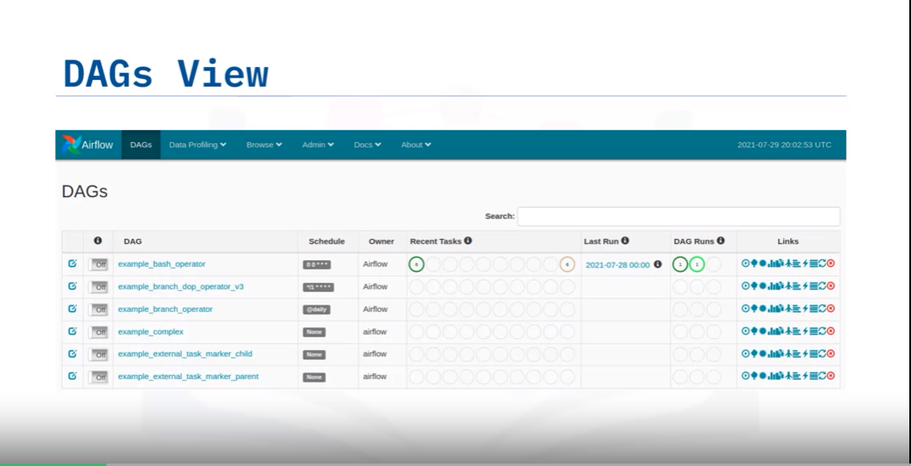

It defaults to the 'DAGs View,' which is a table containing data about each DAG

in your environment.

Each row displays interactive information about a DAG in your environment, such as

Each DAG's name;

Its run schedule, in this case in the crontab format;

The DAG's owner. This one is a built-in example from Airflow;

The status of the tasks from the current or most recent DAG run;

The status of all previous DAG runs;

Plus a collection of quick-links to drill down into more information related to the

DAG.

On the far left, you can drill down to access more interactive details, and

in the next column you can toggle to pause a DAG. All of the DAGs here are currently

not running.

You can visualize DAGs in several ways, as follows.

Start by clicking on the name of the DAG you want to visualize. This DAG, called ‘simple

example’, happens to be running in production, as you can see here by the ‘on’ button.

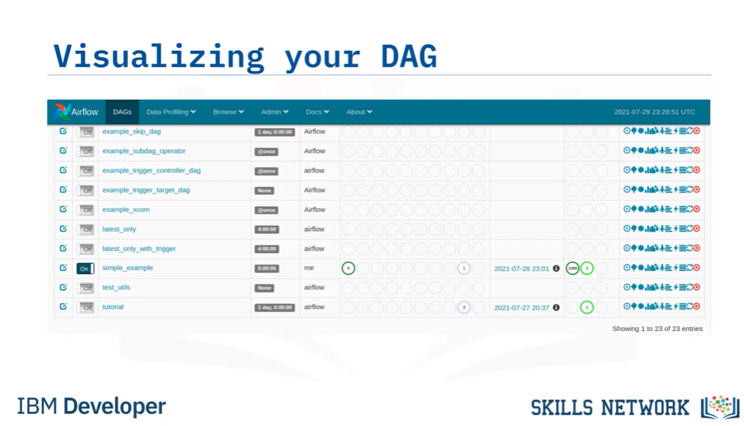

Tree View

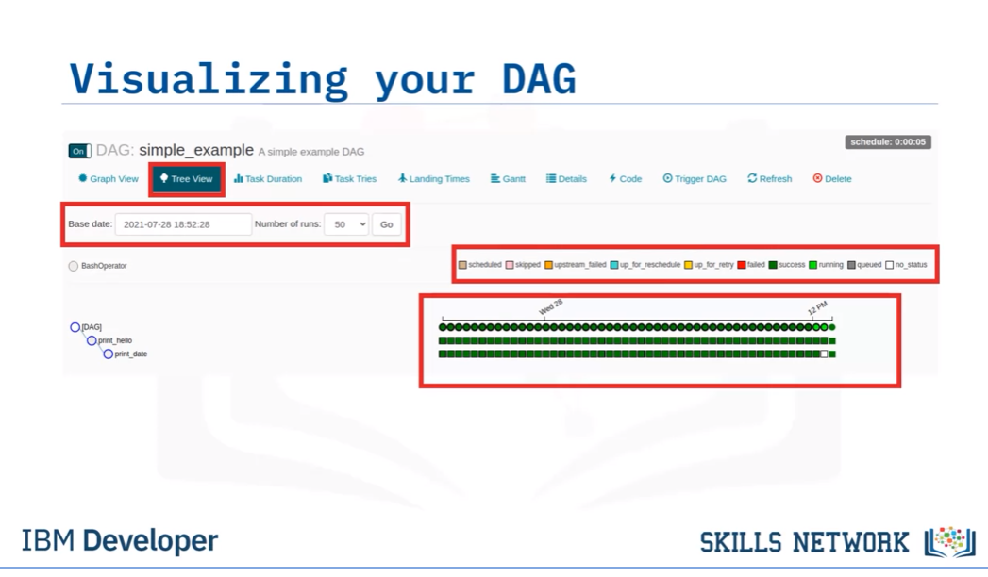

Graph View

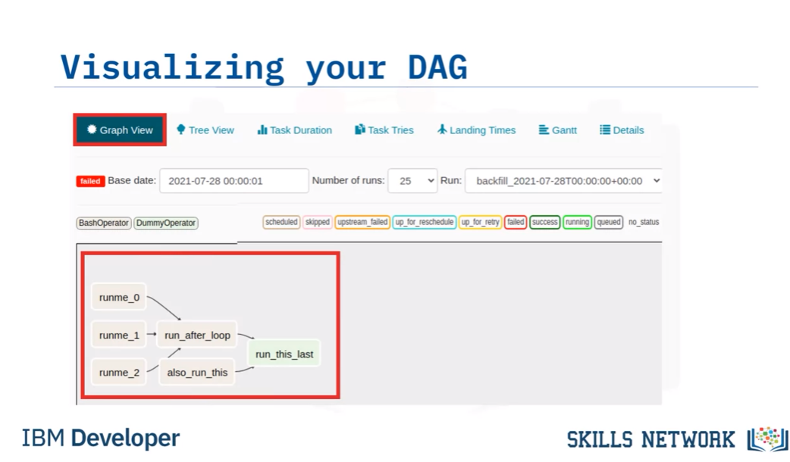

View context metadata for a task

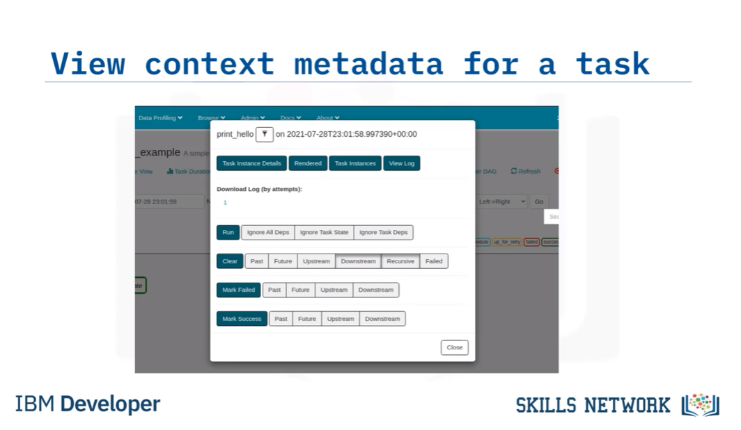

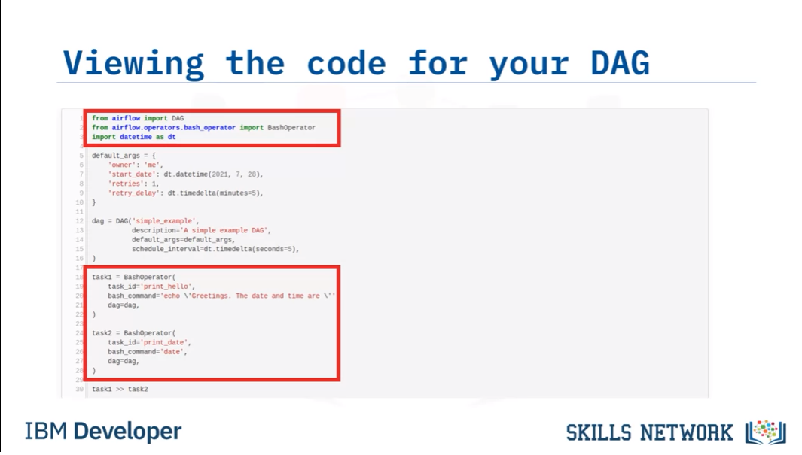

View task duration timelines

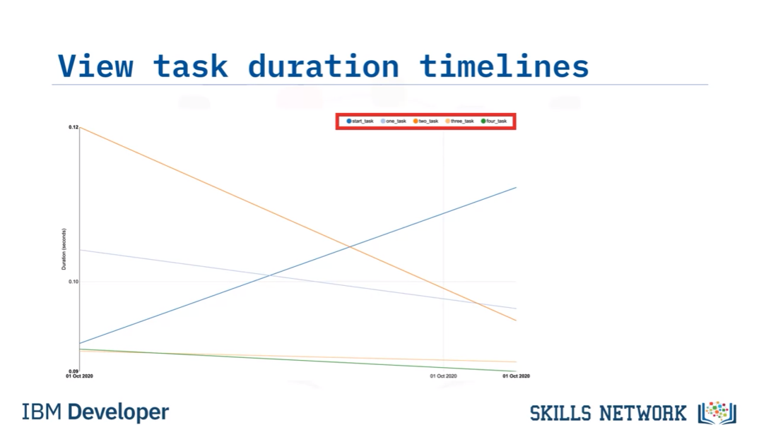

Linux command Grep:

***airflow dags list|grep "my-first-dag"***

grep the result containing “my-first-dag” only

## Build DAG Using Airflow

Welcome to Build a DAG Using Airflow.

After watching this video, you will be able to:

Interpret an Airflow pipeline as a Python script that defines an Airflow DAG object.

List the key components of a DAG definition file.

Create tasks by instantiating operators in your DAG definition file.

Set up dependencies amongst tasks.

An Apache Airflow DAG is a Python script which consists of the following logical blocks:

Python library imports,

DAG argument specification,

the DAG definition, or instantiation,

Individual task definitions, which are the nodes of the DAG,

and finally, the task pipeline, which specifies the dependencies between tasks.

Let's implement a simple Apache Airflow pipeline by writing a DAG definition script.

We will create a very simple pipeline called 'simple example DAG dot py', that:

prints a greeting,

and then

prints the current date and time.

We will also schedule it to repeat the process every five seconds.

Play video starting at :1:13 and follow transcript1:13

Let’s go through the list of logical blocks one by one.

Begin by importing the Python libraries you will need for your DAG.

Here, start by  importing the DAG class from the airflow library,

then the Bash Operator, which you will use to create the two print tasks, and

the date-time module, which you will need for specifying several time-related parameters.

The next block is for specifying the default DAG arguments .

Notice they are specified as a Python dict,

which is just a collection of key-value pairs, enclosed by curly braces.

These are used to specify such things as

the owner of the DAG, which is you,

and its start date, in this case July 28, 2021.

The number of times it should keep trying if it is failing: here only once if it does fail,

and the ‘retry delay’, or the time to wait between subsequent tries,

which in this case is five minutes.

The next block is used for instantiating your workflow as a DAG object.

Here you can specify things like

the name of your DAG, 'simple example';

a description for your workflow, for example, 'A simple example DAG';

the default arguments to apply to your DAG, which,

in this case, are specified by the 'default args'  dict you already defined above;

and finally, scheduling instructions. In this case, the DAG will run repeatedly

on a schedule interval of five seconds once it is deployed.

Next comes the task definition block.

Here we define two tasks, task one and task two, both of which are  Bash Operators.

Their respective IDs are specified as 'print hello',  and 'print date'.

They each call a Bash command, where the first task  will echo ‘Greetings. The date and time

are’, and the second task will print the current date and time using the Bash command ‘date’.

Finally, each task is assigned to the DAG

you instantiated in the DAG definition block above.

The final block is where you specify the dependencies for your workflow, like this.

Here,  the double 'greater than' notation

specifies that task two is downstream from task one.

This means that task one, which we named 'print hello', will run first.

Once 'print hello' runs successfully, task two, or 'print date', will run.

This completes the creation of your Airflow DAG,

and you now have a good idea of the general pattern.

Play video starting at :3:48 and follow transcript3:48

In this video, you learned that:

An Airflow pipeline is a Python script that instantiates an Airflow DAG object.

Key components of a DAG definition file are library imports, DAG arguments, DAG

Play video starting at :4:2 and follow transcript4:02

and task definitions, and the ‘task pipeline’ specification.

You can specify a schedule interval in your DAG definition if you want

it to run repeatedly by setting the 'schedule interval' parameter.

And finally, tasks are instantiated operators,

imported from the Apache Airflow operators module.

Airflow Pipeline Script

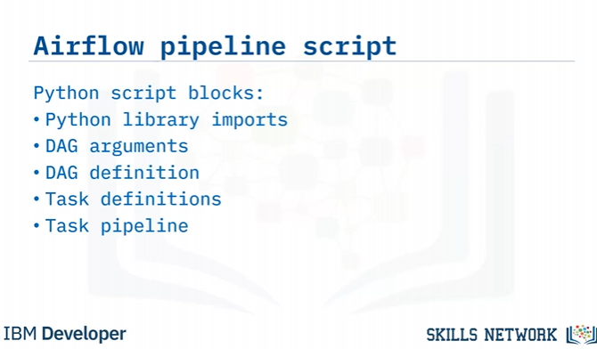

Python script blocks

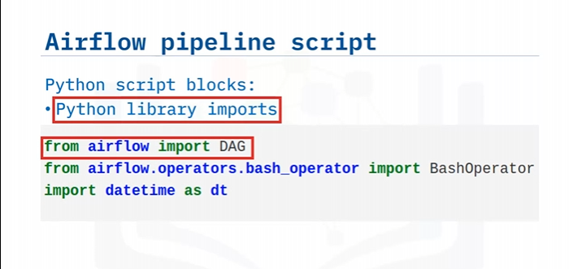

DAG Arguments

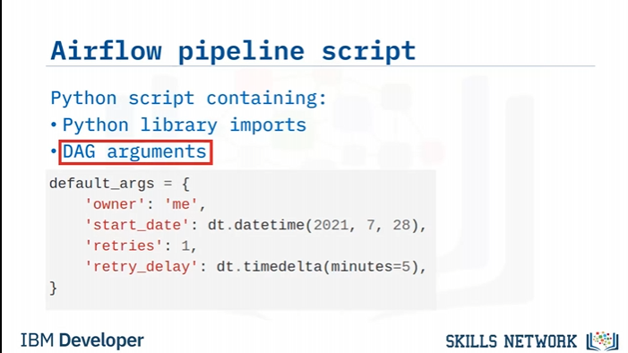

DAG Definition

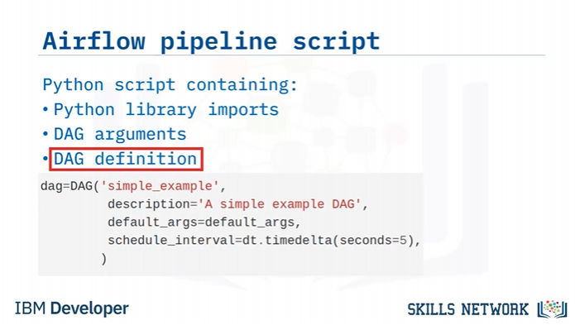

Bash Operators

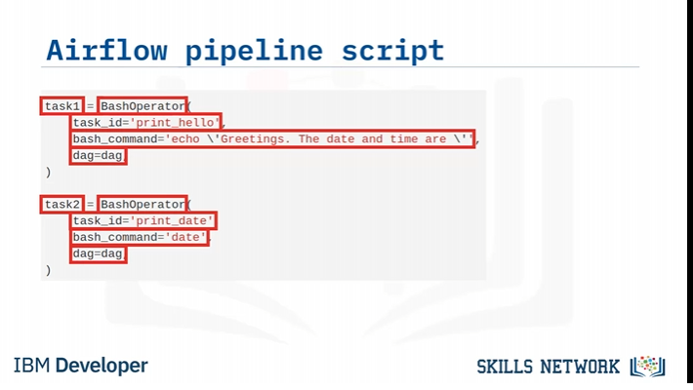

Task Pipeline

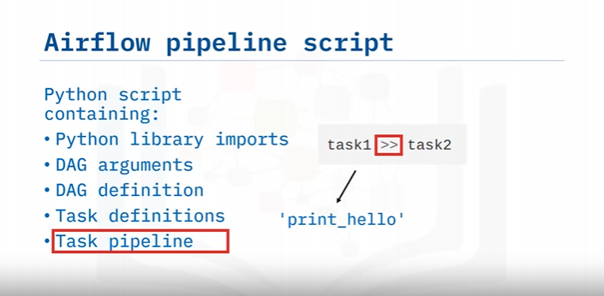

## Airflow Monitoring and Logging

Welcome to Airflow Logging and Monitoring.

After watching this video, you will be able to:

Use logging capabilities to monitor the status and diagnose problems with DAG runs.

Explain accessing emitted metrics such as counters, gauges, and timers.

The logging capability is required for developers to monitor the status of tasks

in DAG runs, and to diagnose and debug issues.

By default, Airflow logs are saved to local file systems as log files. This makes it convenient for

developers to quickly review the log files, especially in a development environment.

For Airflow production deployments, the log files can be sent to cloud storage

such as IBM cloud, AWS, or Azure for remote accessing.

The log files can also be sent to search engines and dashboards for further retrieval

and analysis. Airflow recommends using Elasticsearch and Splunk, which are two

popular document database and search engines, to index, search, and analyze log files.

By default, log files are organized by DAG IDs and Task IDs, and you can find

a specific log file for a task execution using the following path convention:

logs/dag_id/task_id/execution_date/try_number.log

For example, suppose you want to find the log of the first execution try of task 1 in a dummy DAG

at a specific time. You can go to the folder logs/dummy_dag/task1/execution_date/1.log

and if you click the first log file, you can check a lot of useful information, such as:

the running command,

command results,

task results, and so on.

You can also quickly review the task events via UI provided by the Airflow webserver.

You can search events with fields like DAG ID, Task ID, and Execution Date,

and quickly get an overview of the specific DAGs and tasks you are looking for.

Airflow produces three different types of metrics for checking and monitoring components’ health.

These are:

counters,

gauges, and

timers.

Counters are metrics that will always be increasing,

such as the total counts of successful or failed tasks.

Gauges are metrics that may fluctuate. For example,

the number of currently running tasks, or DAG bag sizes.

Timers are metrics related to time duration. For instance,

the time to finish a task, or the time for a task to reach a success or failed state.

Similar to logs, the metrics produced in Airflow production deployments

should be sent and analyzed by dedicated repositories and tools.

Airflow recommends using StatsD, which is a network daemon that can gather

metrics from Airflow and send them to a dedicated metrics monitoring system.

For metrics monitoring and analysis, Airflow recommends using Prometheus,

which is a popular metrics monitoring and analysis system.

Prometheus can also aggregate and visualize

metrics in a dashboard for more interactive visual analytics.

In this video, you learned that:

You can save Airflow logs into local file systems

and send them to cloud storage, search engines, and log analyzers.

Airflow recommends sending production deployment logs to be analyzed by Elasticsearch or Splunk.

With Airflow’s UI, you can view DAGs and task events easily. You also learned that

The three types of Airflow metrics are counters, gauges, and timers.

Play video starting at :4:1 and follow transcript4:01

Airflow recommends that you send production deployment

metrics for analysis by Prometheus via StatsD.

Logging

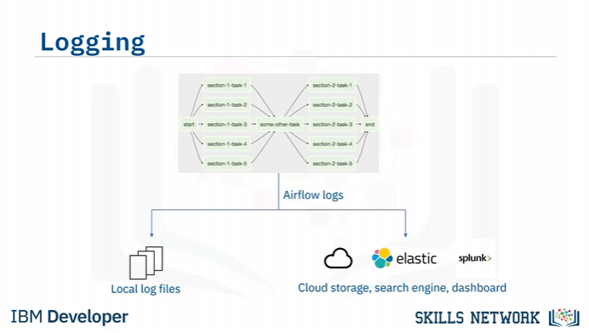

Airflow Log files

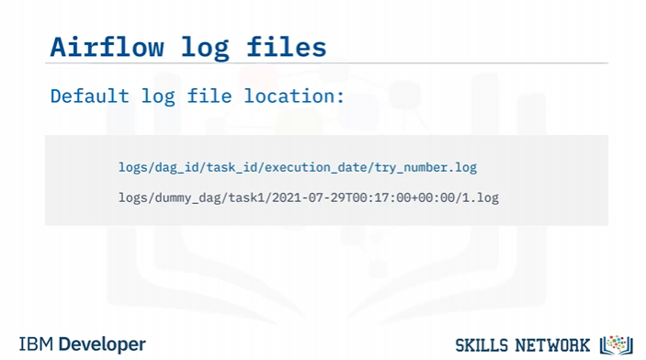

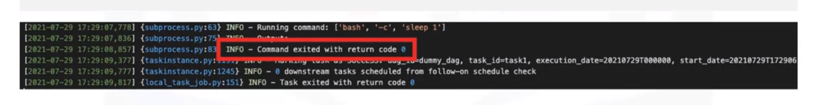

Review task events through the web UI

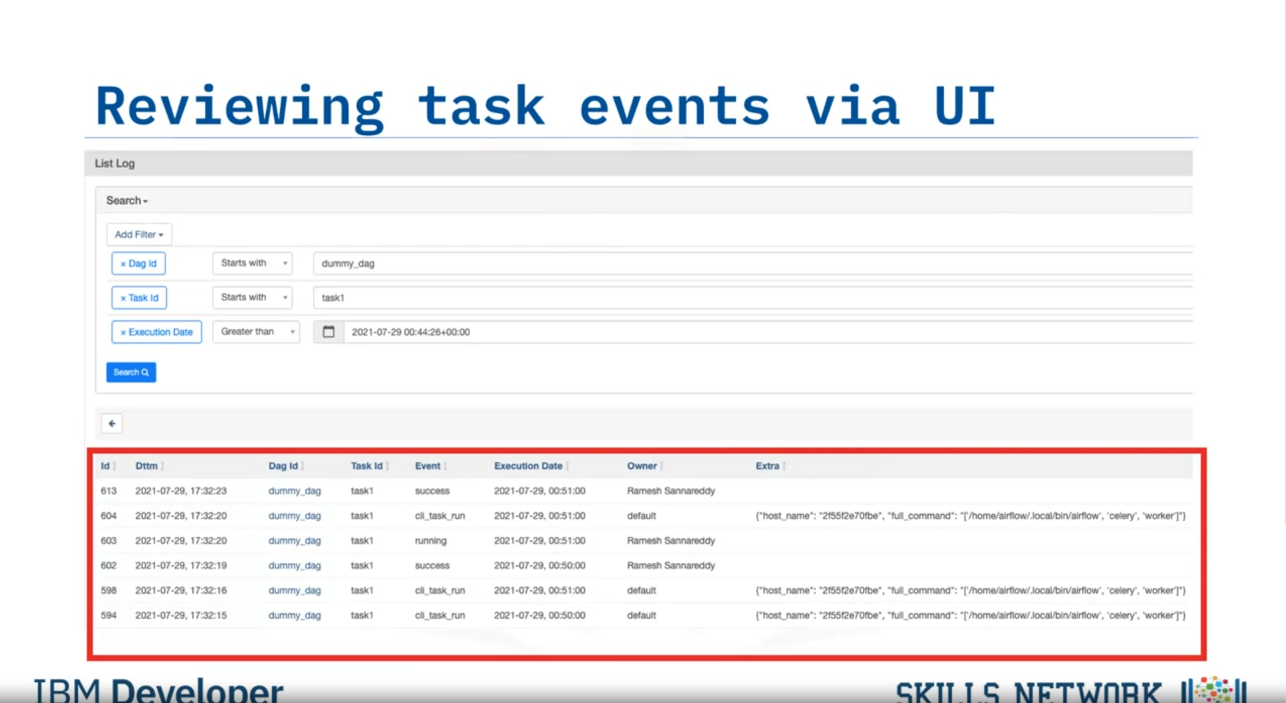

Monitoring Metrics

Counters, gauges, Timers

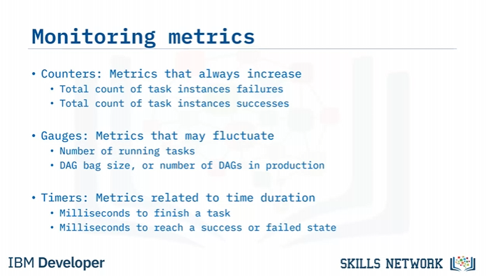

Storing and Analysing Metrics

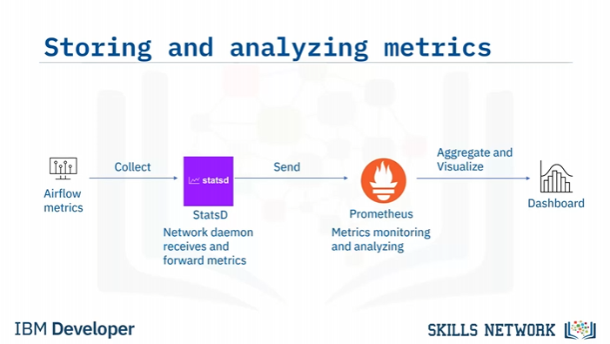

Similar to logs, the metrics produced in Airflow production deployments

should be sent and analyzed by dedicated repositories and tools.

Airflow recommends using StatsD, which is a network daemon that can gather

metrics from Airflow and send them to a dedicated metrics monitoring system.

For metrics monitoring and analysis, Airflow recommends using Prometheus,

which is a popular metrics monitoring and analysis system.

Prometheus can also aggregate and visualize

metrics in a dashboard for more interactive visual analytics.